**CSC 335 Data Communications and Network I**

**Homework 3**

1. (1 point) All signals (electronic, electromagnetic, optical) experience communication impairments. For example, the signal strength reduces along the way. The quality of signal can be shown by an eye diagram, which is an oscilloscope display of a digital signal that repetitively sampled from a receiver end. To get the eye diagram, people send 16 signals of 4 bits (0000, 0001, 0010, 0011, 0100, 0101, 0110, 0111, 1000, 1001, 1010, 1011, 1100, 1101, 1110, 1111) using square wave where 0 is low (e.g. -5v) and 1 is high (e.g. 5v). In other words, it is a layered view of each of the different bit transition combinations. So, it provides a composite picture of the overall quality of the physical characteristics, such as amplitude variations, timing uncertainties, and infrequent glitches. Please name and explain the three communication impairments that any signal experience. Then distinguish between dissipation and attenuation.

**Noise: any undesirable signal that negatively affects the quality of the desired signal, such as static or crackle in radio signal.**

**Loss: low or no power signal because the distance of the signal is too far. There are two types of losses: dissipation and attenuation.**

**Delay: data being transmitted to a node on the network is higher than the bandwidth available.**

**Dissipation: energy gets scattered in many directions and loses its power**

**Attenuation: energy is absorbed (possibly to a different type of energy) and loses its intensity.**

receiver

transmitter

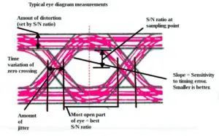

transmit

1110

0010

0001

0000

1. (1 point) When you transmit message/movie from your desktop to your sibling’s desktop in the same house, you are using the Ethernet for information dissemination, assume both desktops are attached to the same router using Ethernet cable. Please identify the transmission delay for the cases below. Please include all calculation steps.

|  |  |  |
| --- | --- | --- |
| Ethernet Cable Type | File Size | Transmission Delay |
| Cat5e: 1000 Mbps for 100 meters | 1 bit | **0.000001 ms** |
| Cat5e: 1000 Mbps for 100 meters | 1500 bytes | **0.012 ms** |
| Cat7: 10 Gbps for 100 meters | 1500 bytes | **0.0012 ms** |

*Extra Reading: Why I put 1500 bytes here? It is way smaller than a video, right? It is because there is a maximum size for each layer. For example, on network layer, the maximum packet size is 65535 bytes. On Data Link layer, the maximum frame size for Ethernet is 1500 bytes. The maximum frame size for another protocol on the Data Link layer, WiFi (802.11), is 2304 bytes. From a high level of view, when you transmit a video/large file, it is break into different packets first. Then, each packet is break into multiple frames. You may already notice that, the protocol data unit (PDU) on network layer is called packet, and the PDU on Data Link layer is called frame.*

1. (1 point) After the file is transmitted to the communication line, now we need to move them from one device to another. We call it propagation. Propagation delay measures the flight time of packets over the transmission link. The speed of propagation through coax cable is about 2/3 of the speed of light ($3×{10}^{8} m/s$). If the cable length between you and your friends’ house is 3 miles, what is the propagation delay? (hint: 1 mile = 1.6 km)

**24 milliseconds.**

1. (2 points) Is the signal *x*(*t*) = cos2(2π*ft*) periodic? Why? Attach your plot. **Yes, the signal is periodic, as proven by the plot.**

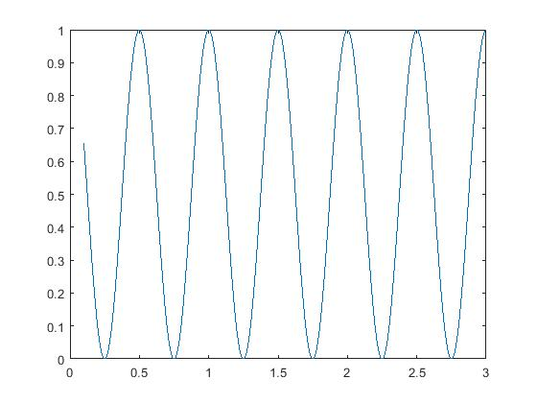

1. (2 points) Pleasese Matlab or R to plot a periodic signal made of several sinusoids given by:

*x*(*t*) = -0.5 + 0.1×cos (10π*t*) + 0.2×cos(20π*t* + π/6) + 0.5×cos(30π*t* + π/4) + 0.2×cos(80π*t* + π/3). Use an appropriate time scale. Attach your plot.

